Table of Contents

INTRODUCTION2

PERIPHERALS3

PERIPHERALS CODE5

START/END DETECTION6

HAND MOTION DETECTION7

DIAGRAM8

CONCLUSION9

References/Figures10

To the Reader11

**INTRODUCTION**

This project entailed the development of an interactive maze, engaging players in a competitive pursuit to achieve the shortest completion time. Undertaking this endeavor presented a personal challenge, necessitating a comprehensive grasp of PWM (pulse width modulation) principles and their effective application through Verilog programming. While intellectually demanding, I successfully navigated this intricate landscape, owing much of my achievement to the invaluable guidance and mentorship of our esteemed professor. His insights affirmed that, while the path may be arduous, mastery of PWM was attainable through dedicated study.

Having undertaken the rigorous process of acquiring proficiency, I acquired the capacity to adeptly control servo motors, harnessing their functionality to precise specifications. Armed with this newfound competence, I embarked on a creative pursuit, crafting a dynamic maze with multi-dimensional tilting capabilities—right, left, forward, and backward—facilitating a seamless journey for a ball from initiation to destination within the maze's confines.

However, the pivotal question of control design emerged as a focal point. How best to empower players with the capability to manipulate maze orientation? What input mechanisms could be seamlessly integrated into the project, enabling players to influence the maze's tilt dynamics according to their preferences? Amid a spectrum of potential options—ranging from conventional physical controls like buttons and switches to leveraging the onboard accelerometer—a more innovative and sophisticated solution beckoned: touchless wave motion detection. Motivated by its strategic significance and enhanced user experience, I proceeded to orchestrate the implementation of an integrated circuit board housing IR detectors, elevating the maze's responsiveness by interpreting and responding to subtle hand gestures.

At the entry/exit points of the maze, there are two significant elements: a start detection mechanism and a stop detection mechanism. Their primary function is to initiate a timer, which is prominently displayed on the DE10 Lite board using the HEX displays. Additionally, they halt the timer and save the recorded scores. Players can easily access their scores by using the switches located on the board. This user-friendly setup ensures a straightforward process for tracking and reviewing performance results.

**PERIPHERALS**

* **6x IR (Infrared) Sensors**
* 4 sensors in harmony were used to create hand moton detector as input from the players.
* 2 were used for the start/end timer on the maze.
* All sensoors are indicated with large arrows. These sensors consisted of three pins:
  + VCC
  + Ground
  + Digital IN
* Digital In was connected to the Arduiono pins on the FPGA board to get a signal anytime a motion was detected at a specific distance from the sensors.
* The Digital In is an Active low signal, inverse asserted when motion detected.

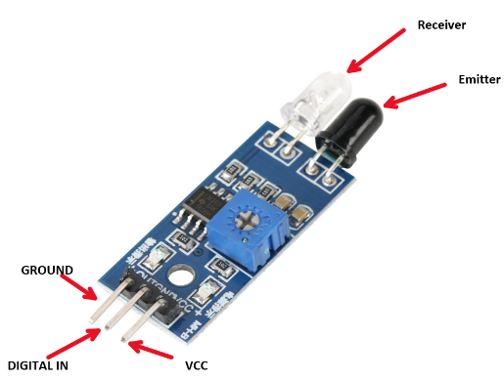



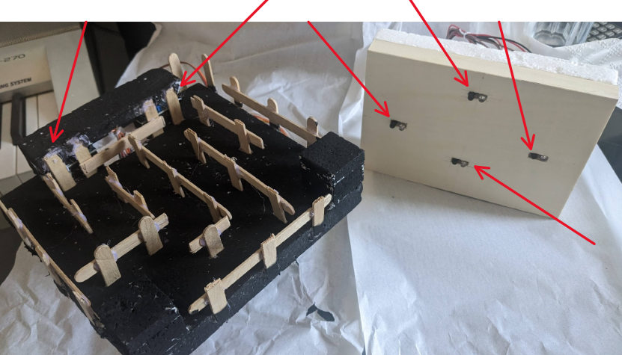

* **2x 9g Servo Motor**
  + This setup was the hardest to figure out because of two main components. First was to understand how PWM (Pulse Width Modulation) works, and second was to make them work together in conjuction with each other to operate a platfrom that can tilt left, right, front and back.
  + 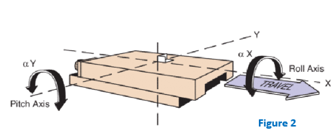The base motor controlled one axis of orentiation, the Pitch, which rotated the top motor. Thus, the top motor had control of the Roll axis, allowing the maze to have freedom of axis in both orientation as in (Figure 2).
  + The Servo Motor has three Pins (Figure 5):
  + VCC
  + Ground
  + Digital IN
* Unlike the Digital IN for the IR sensors, the Servo motor digital signal was not as simple as an Active Low. It uses PWM (Figure 3) signals at:
  + Period: 50 Hz (20 ms)
  + Duty Cycle: 1 – 2 ms (5% - 10%)
* 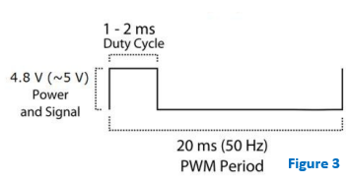The reason the Duty Cycle varies from 1 – 2 ms (5% - 10%) is because that is what tells the motor what position to be at. (Figure 4)

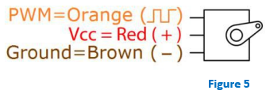

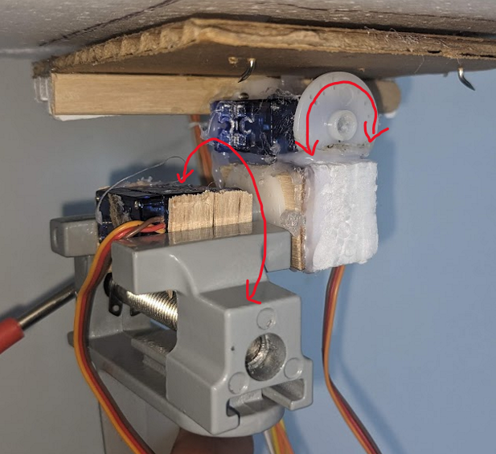

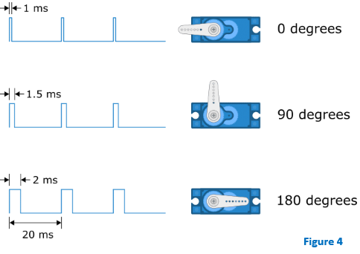

**PERIPHERALS CODE**

* **IR (Infrared) Sensors**
  + Code was a simple Assertion if motion is detected:
  + ARDUINO_IO are the pin inputs for the detectors. The code above implies if motion is detected, I get a signal. I had 6 of these ports as inputs for the IR.
* **Servo Motor**
  + To understand this code, we must grasp the knowledghe of PWM.
  + I converted the onboard CLOCK of 50 MHz to 50 Hz dividing by 1 million. This was done by adding 1 to an artifial counter for the servo to achieve 50 Hz on every positive clock edge untill 1 million, and then resetting it back to 0.
  + Since the onboard clock consists of million clock rises for one period, referring back to Figure 4, I want to only tilt the maze slightly in direction of choice, by roughly 5 degrees. This means, I will need a duty cycle that will allow me to move betwee 95- 85 degrees.
  + In order to let the maze stay in a neutral position, the motors state must remain at 90 degrees, which means a duty a cycle of 7.5 percent. Roughly 0 – 52 000 out of the million clock rises.
  + 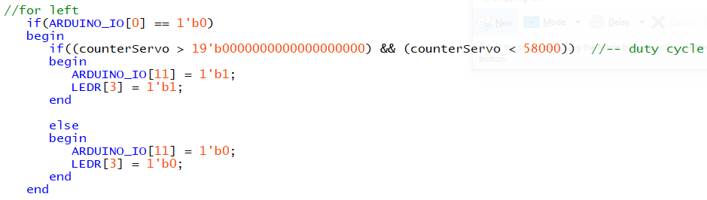In order to tell the motor to rotate 5 degress either way, I need to send a PWM signal of 0 – 58 000 or 0 – 52 000 (about 3000 clock rises) to tilt towards either direction. Below is a snippet for one of the directions:
  + Here, ARDUINO_IO[0] is one of the motion detectors for the players hand.
  + ARDUINO_IO[11] is the motors pin output which sends an assertion between that duty cycle period.

**START/END DETECTION**

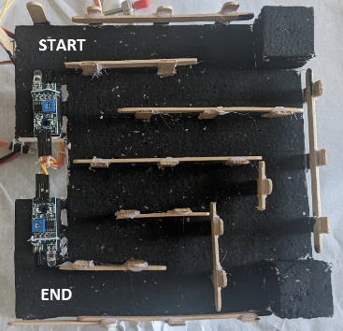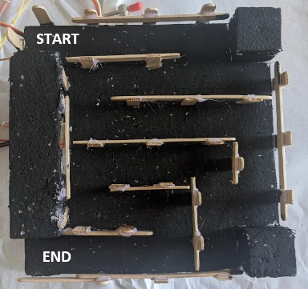To track the score, I physically housed two IR sensors on the maze which allowed me to incorporate a timer that starts when the ball is released at the beginning of the maze and stops when the ball reaches the end. The timer's display was shown on the onboard 7-Segment HEX display.

The issue was that upon the release of the ball, the ball might trigger the start game again. Therefore, I used an SR Latch that would set a StartGame trigger (Set) when the ball is detected by the start detector, and the only way to StopGame trigger (Reset) is for the end detector to be asserted.

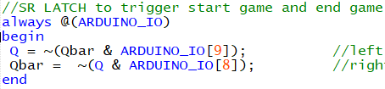

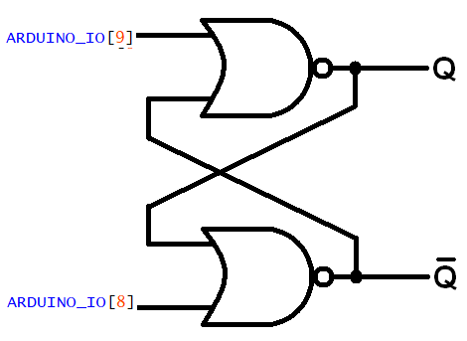



**HAND MOTION DETECTION**

At first, I intended to utilize the built-in G-sensor to react to the maze's motions. Nevertheless, my goal was to create a completely touchless game, which led me to develop a custom sensor. This involved integrating a board capable of detecting hand motions. I achieved this by employing four IR sensors that activate corresponding left, right, up, or down responses to adjust the PWM of the motors.

**Pseudo Code:**

if LeftDetected & NOT RightDetected  
 *do LEFT tilt code*……

if RightDetected & NOT LeftDetected  
 *do RIGHT tilt code*……

if NOT RightDetected & NOT LeftDetected  
 *do middle position code*…

if UpDetected & NOT DownDetected  
 *do UP tilt code*……

if DownDetected & NOT UpDetected  
 *do DOWN tilt code*……

if NOT UpDetected & NOT DownDetected  
 *do middle position code*…

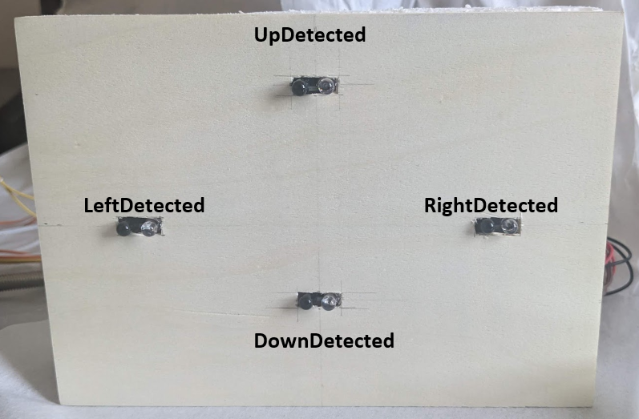

**DIAGRAM**

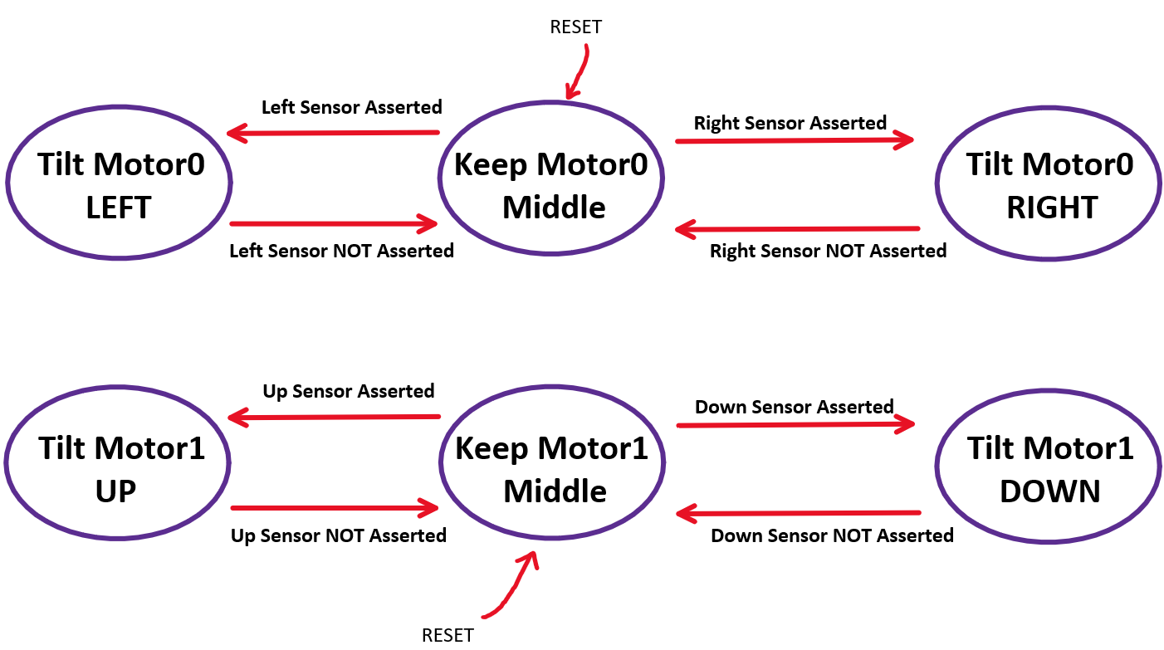This project comprises several distinct modular components. To facilitate comprehension, I will divide it into sections for easier understanding.

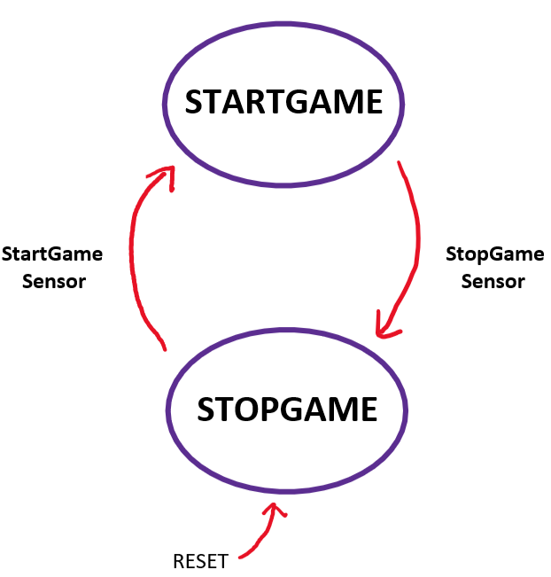

**CONCLUSION**

Initially, my plan was to utilize the onboard G-sensor to respond to the maze's movements. However, I aimed to design a game that operates without physical touch. This aspiration drove me to create a custom sensor. I achieved this by integrating a specialized board capable of detecting hand motions. This innovation involved the incorporation of four IR sensors that respond to the PWM signals by triggering movements in the corresponding directions: left, right, up, or down.

To enhance the gameplay experience, I integrated two additional sensors within the maze – one for detecting the start and the other for recognizing the end point. This innovation enabled the implementation of a scoring system, with the objective of achieving the lowest completion time. Moreover, I developed a state machine that efficiently manages various game states. This facilitated the saving of the top three scores onto a scoreboard, which is automatically stored.

Furthermore, I encountered limitations imposed by the physical components I employed. The maze's performance became somewhat erratic due to these constraints. With access to more suitable tools and improved servo motors, I am confident that I could eliminate the issue of shaking entirely.

Summing up, working with HDL coding proved to be both engaging and enjoyable. This project taught me valuable lessons, and I am enthusiastic about continuing my learning journey.

**The videos below showcase some parts of the project along with the end result.**

* Scoring, Saving, Start/End Triggering:

<https://www.youtube.com/watch?v=nA-JdZgRjiY&ab_channel=Tarzan>

* Complete Demo:

<https://www.youtube.com/watch?v=XcKc6ZQHN9o&ab_channel=Tarzan>

**Figures**

[1] https://ftp.intel.com/Public/Pub/fpgaup/pub/Intel_Material/Boards/DE10-Lite/DE10_Lite_User_Manual.pdf

[2] https://www.linkedin.com/pulse/motion-basics-how-define-roll-pitch-yaw-linear-systems-collins/

[3, 4, 5] DE-10 lite User Manual, Terasic, Hukou Township, Taiwan, 2017. Accessed: Nov. 25, 2023. [Online].Available:https://ftp.intel.com/Public/Pub/fpgaup/pub/Intel_Material/Boards/DE10-Lite/DE10_Lite_User_Manual.pdf